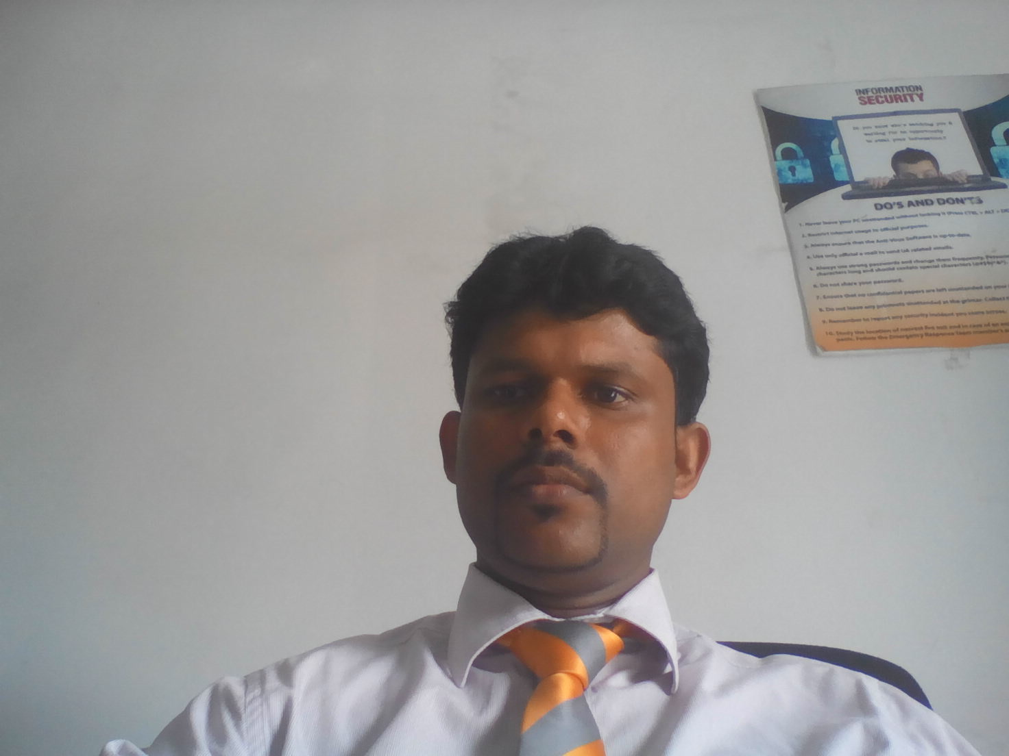

Kamalapatham Nishanthan
No:17,07th Cross, Iruthayapuram-East, Batticaloa
Mobile : +94 77 2990311
E-mail : nisha_harshaa@hotmail.com
Date of Birth : January 03rd 1981
Driving License : B2260938
Work History

December 17th 2013 to Still now
Worked as a Manager – Sales Force Recruitment Eastern Zone and Sales Manager at Union Assurance PLC, working regions are Batticaloa, Kalmunai and Trincomalee.

- To support sales force recruitments for all region to achieve theirs targets through the new quality recruits in our Eastern Zone
- Contact career presentation in all regions for new recruitment methodology.
- Identify quality recruitment sources, collect the leads
- To motivate new recruits to achieved theirs local and International awards (MDRT, IQA, Foreign Tours, Brilliant Starters, etc..)
- IBSL Training
- Motivation Seminars for all advisors

October 01st 2009 to 10th December 2012
Worked as a Junior Executive at AVIVA NDB Insurance PLC – Batticaloa

● Second line Member & Regional Moderator
● Office Administration
& Asset Register Maintain
& Stationers Maintain
& Petty cash Maintain
●Training
& IBSL Training
& Field Staff Training
● Product Training
● Induction Training for New recruits
● Daily Meeting for field staff
● Motivation for field staff
& IT related Training
● iwealth planner portal – how to using field staff
● CMM usage for field staff
● Customer Service
& To provide a valuable customer service
& Claims
& Funds related Service – Surrender/Discharge/Loan/Partial Withdrawal

● Seminars and Meetings
& Recruitment seminars
& Public meetings

Cashiering
& Receipting all related payment
& Receipting for all related
& Prepared Cash Book Summary
& Petty Cash Maintained
& All financial related reports are sent to Head Office on time
February 10th 2005 to 31st December 2008

Warehouse Supervisor at World Vision Lanka

● properly accounted for all commodities arriving and leaving to the warehouse.

● Plan Storage place in warehouse in advance

● Truck Inspection, Vehicle Maintenance & Maintain Assets Inventory Ledger.

● Scrutinize all waybills to ensure that the commodities are of correct quantities and quality a

Manifested on the waybill.

● Store everything according to World Vision Standards.

B. Transport and Vehicle Management
- Operate and maintain emergency communication equipment VHF/HF
- Maintain vehicle log book by daily recording movements of vehicle fuel consumption and mileage done. Alert supervisors of any repair due to vehicle

Lorry arrangements, Movements, Proper payments, verify the documents According to the

Advance distribution plan.
- Other duties assigned by supervisor.

Awards / Training Programs / Obtained Certificate

● I got the “Living of Values” award for 2011 AVIVA NDB Annual Conference.
● I have completed in “Customer Care & Team Motivation” Training at AVIVA NDB Insurance PLC
● I have participated in “How to Overcome Challenge” workshop at AVIVA NDB Insurance PLC
● I have Successfully completed World Vision Asia Tsunami Response Team “ Skill Assessment Workshop” in Srilanka (MERLOT)
● I have successfully participated in “Local Capacities for Peace / Do no harm” Training
● I have successfully completed National Youth Ranger Leader Training at National Youth Council Eraminiyaya, Hambantotta, Srilanka
& Leadership Skill Training
& Self Confident
& first aid
& IT Skill
& Team work & Physical Training.
● I have successfully completed “Outward Bound” Certificate course (Conducted by the Outward Bound Trust of Srilanka an Affiliate of Outward Bound International, Utah, and USA) Programmed by National Youth Corps
& Rock Calming
& Rope course
& Water Activities
& Expedition
Sports Activities

● Inter YRLTC Athletics meet 2003 – 100 Meter Running. 1st Place. Held on 07th August 2003 at Embilipitiya Mahawali Stadium. (Programmed by Youth Corps)

● Foot ball 02nd Place & Volley ball 03rd Place in Provincial level at Trincomalee.

● Participated Volley ball in National & Provincial Level

● I am Participate Youth Club Sports Meet (Athletics, Football, Volleyball, Elle & Cricket)

Computer Skills & Professional Qualification

●I have completed NCAT (National Certificate in Accounting Technicians-New) at BT/Technical College Batticaloa – Full Time (2000/2001) – Merit Pass

● Completed In Diploma in Information Technology (DIT) at MYOWN Computer (Pvt) Ltd. Batticaloa. (2000/2001)

● Completed In Computer Program Operator (CPO) for 6 Months at Rural Vocational Training Center at Arayampathy. (Ministry of Tertiary Educational & Training Vocational Training Authority in Srilanka) (2002)

● I have successfully completed Basic Information Technology at E-Wiss Career Training (Pvt) Ltd. Colombo – 03. (2003)

● Below Computer operating system & application I can do well.

Windows O/S (2000/NT/XP/Windows Vista)

Word Processing (MS Word)

Spread Sheet (MS Excel)

Presentation (MS Power Point)

Database Management (Ms Access/Visual Fox Pro/Dbase III +)

DTP (Desk Top Publishing) Works

Internet & E-mail

Language Skills

Language | Fair | Good | Excellent
English (Read, Write & Speak) |  | ☑
Sinhala (Read, Write & Speak) |  | ☑
Tamil (Read, Write & Speak) |  |  | ☑ (Native)

Academic Qualifications
- Following external degree for BBA in South Eastern University of Srilanka at Oluvil

G.C.E (O/L) December 1996  Index No:- 65247663 |  |  |  |  |  | G.C.E (A/L) August 1999  Index No: 9787569
No | Subject | Grade | No | Subject | Grade | No | Subject | Grade
01 | Tamil Language | D | 05 | Science | C | 01 | Business Studies | A
02 | Religion | D | 06 | Social Studies | C | 02 | Accounting | S
03 | Mathematics | C | 07 | Agriculture | C | 03 | Economics | S
04 | English Language | C | 08 | Art | C | 04 | Agricultural Science | S
Obtained Marks: - 193

NON – RELATED REFEREES

Mr.M.Julian Sasikumar
Regional Manager – Kalmunai Region
Union Assurance PLC
Phone: +94- 067 22 22633
Mobile +94- 077 8171940
Rev.Fr.R.Thiruchelvam
Parish Priest.
Sacred Heart Church, Iruthayapuram
Batticaloa.
Phone: 94-065-22 24969

I declare that the particulars contained in this application are true and correct to the best of my knowledge.

Date Signature

_________ ____________

